Atanas Kuzmanov 0830668
CE301 Interim Report
P.A.C.I.N.G.S. – PDA Android Campus Information Navigation Guidance System

Supervisor: Professor Huosheng Hu


Android Logo used on Cover Page of this document reference:
[1] “Android | Brand Guidelines.” [Online]. Available: http://www.android.com/branding.html. [Accessed: 30-Nov-2010].

Contents
I. Introduction 5
1. Purpose 5
1.2 Scope 5
II. Overall Description 5
2. Product Perspective 5
2.1 System Requirements 5
2.2 Interfaces 6
2.3 User Characteristics 6
2.4 Site Adaptation Requirements 6
2.5 Product Functions 6
2.6 Constraints 7
2.7 Safety and Security considerations 7
2.8 Assumptions and Dependencies 7
3. Specific Requirements 7
3.2 External Interfaces 7
3.3 Functions 8
3.4 Performance Requirements 8
3.5 Logical Database Requirements 8
3.6 Design Constraints 9
3.7 Software System Attributes 10
3.8 Organizing the Specific Requirements 10
4. Change Management Process 11
III. Design 12
1. Architecture Overview 12
2. Design Considerations 14
3. Architectural Strategies 14
3.1 Architecture Types 14
4. System Architecture 15
4.1 System Rational 15
4.2 Modular Decomposition Rational 16
5. Policies and Tactics 17
6. Database Design 17
IV. Work Quality 18
V. Bibliography and Background Reading 20
Appendix A 23

Introduction

Purpose
The purpose of this Interim Report is to outline the specification requirements and design specification of a “PDA Android Campus Information Navigation System” application which is to be developed, and also to demonstrate my progress made so far.
In order to provide a well structured document I will use my knowledge gained in last year’s CE201 module[2], more specifically knowledge about Specification[3] and Design[4] and the documents submitted for last years’ CE201 – “Software Requirements Specification”[13] and “Software Design Specification”[14].

Scope
The goal of this project is to create an application based on an Android[7] Operating System for an Android PDA (Personal Data Assistant) Smartphone to help students and visitors have a better experience in the University of Essex[12] by allowing them to navigate with ease.

Overall Description

Product Perspective

System Requirements
User’s experience is dependent on the performance of the Operating System and the Smartphone running the application. The following specifications were inspired from the HTC Legend specifications[5].
- Operating System
- Android™ 2.1 Operating System or later. An Android OS below the 2.1 version might not have support for APIs needed to run the software product.
- Recommended: Android™ 2.1 (Éclair) Operating System with HTC Sense™
- Default Android™ 2.1 applications and APIs
- Hardware Requirements
Minimum hardware requirements:
- CPU Processing Speed: 600 MHz
- Memory:
  - ROM: 512 MB
  - RAM: 384 MB
- Display
  - Type: AMOLED capacitive touch screen with pinch-to-zoom capability
  - Resolution: 320 X 480 HVGA
  - Screen size: 81.2mm (3.2")
- Built in Camera
- GPS
- Wi-Fi/3G/Cell
- G-Sensor/Accelerometer
- Digital Compass
- Recommended: HTC brand Smartphone (generally standard and compatible device)

Interfaces
The application will have to interface with:
    - System Interfaces
- SQLite[6] Database – Local database running on the device.
    - Software Interfaces
- Android Operating System – Operating System the device is running.
    - Hardware Interfaces
- Smartphone/PDA (Personal Data Assistant) – Device used to run the application.
    - User Interfaces
- The user will interface with the application through the Smartphone/PDA (Personal Data Assistant) device.

User Characteristics
The intended user will be able to use the application with ease. No high degree of technical knowledge will be required with the minimum requirement of basic understanding of how to use a PDA device.

Site Adaptation Requirements
For the “Level 0: Application Base” no site adaptation will be necessary. (See “Figure 7. Use Case Diagram 3”)

Product Functions
    - User functions
The program is to show a desired by the user location on digital maps and present information in text format to the user, explaining how to reach the destination.
    - Data storage
All the required data will be stored in a local SQLite database (the supported by Android OS database) on the device.
    - Future proof functionality
If time and other resources suffice the system will be further developed by implementing subcomponents from “Level 0: Application Base Extended”. (See “Figure 8. Use Case Diagram 4”)
Future development of system, further to the project’s Initial Report[9]:
- If time and other resources suffice further levels of the functionality of the system can be developed and implemented.
- If time and resources suffice, to implement a routing algorithm for navigating the user from current location to desired destination.
- If time and resources suffice, to implement Administrator Interface.
- If time and resources suffice, the system can be adapted to guide visually impaired people by streaming text, voice or other media information from a server. [10]

Constraints
This section of the document presents items which will limit the developer’s capabilities.
- Regulatory policies
- Data Protection Act (DPA) 1998[11]
- University of Essex policies[12]
- Hardware constraints
- User’s Smartphone performance and capabilities.
- Interface constraints
- Interfaces connected to the application may pose constraints or bottlenecks depending on their performance.
- Parallel operation
- Using the application in parallel with other application may cause poor device performance and poor user experience.
- Reliability
- Reliability will be dependent on the database consistency.

Safety and Security considerations
- Safety – The user must not allow to be distracted by the application and always be wide awake.
- Security – N/A

Assumptions and Dependencies
- It is assumed that the application will be used only on the University of Essex’s campus as the product is specifically developed to work only on the campus’s grounds.
- It is assumed that the user will only search for locations on the University of Essex’s campus.
- It is assumed that the device is running Android™ 2.1 Operating System and it has the corresponding default applications and APIs.
- It is assumed that the device’s Operating System is in good working order.
- It is assumed that the device is in good working order and has all the needed hardware components.
- It is assumed that the System Requirements are met.

Specific Requirements

External Interfaces
- This section describes the inputs and outputs from the system.
- User Interface
- Name: User Interface
- Description: The user will interface with the application through the Smartphone/PDA (Personal Data Assistant) device, more precisely through the layout on the screen of the device.
- Source input: Entering destination.
- Destination output: Showing location on digital map on the Smartphone’s screen.
- Valid range: All the destinations on the University’s campus which have been entered in the database.

Functions
- The system shall perform validity checks on the user input in order to prevent SQL injection.
- Main functionality flow
- The system will take user input.
- The input will be compared to database data.
- If a matching entry is found the corresponding data is passed to corresponding functions.
- The corresponding functions use the data to deliver the output to the user.
- If a match is not found a relevant error message is displayed and the user is prompted for input again.
- Any exceptions will be handled.

Performance Requirements
The application is to be unobtrusive and as efficient as possible as it is constrained by the device’s limited amounts of memory and processing power.

Logical Database Requirements
The initial Database will be very simple and it will develop and grow along with the functionality of the product.
Square Entity
Description: Squares table will contain available University campus Squares, their Pixel Coordinates for marking them onto an image and Information about how to reach the desired Square.
Relationships: Square has “one to one-or-many” relationship with Entrances as one Square can have one or many Entrances.
ID | SQUARE | SQ_PIX_COORD_X | SQ_PIX_COORD_Y | INFO
1 | SQ1 | X1 | Y1 | INFO_SQ1
2 | SQ2 | X2 | Y2 | INFO_SQ2
3 | SQ3 | X3 | Y3 | INFO_SQ3

Square_Has_Entrance Entity
Description: Table representing the relationship between Squares and Entrances.
Relationships: Connects Square and Entrance entity in a “one to one-or-many” relationship.
Auto number | SQUARE | ENTRANCE
1 | SQ1 | 1NW
2 | SQ3 | 3NE
3 | SQ3 | 3NW

Entrance Entity
Description: Entrances table will contain available University campus entrances associated with corresponding University Squares. It will also contain their Pixel Coordinates for marking them onto an image and Information about how to reach the desired Entrance.
Relationships: One Entrance has a “many to one” relationship with a Square as one or more Entrances are associated with exactly one Square. Entrance also has a “one to one-or-many” relationship with Rooms.
ID | ENTRANCE | ENT_PIX_COORD_X | ENT_PIX_COORD_Y | INFO
1 | 1NW | X1 | Y1 | INFO_E1
2 | 3NE | X2 | Y2 | INFO_E2
3 | 3NW | X3 | Y3 | INFO_E3

Entrance_Has_Room Entity
Description: Table representing the relationship between Entrances and Rooms.
Relationships: Associates Entrance and Room entity in a “one to one-or-many” relationship.
Auto number | ENTRANCE | ROOM
1 | 1NW | 1NW.4.1
2 | 3NE | 3.008
3 | 3NW | 5A.101

Room Entity
Description: Rooms table will contain available University campus rooms associated with corresponding University Entrances. It will also contain Information about how to reach the desired Room.
Relationship: For the “Level 0: Application Base” stage of the project the Room entity will have a “many to one” relationship with an Entrance as one or more Rooms are associated with exactly one Entrance. In later stages of the product this relationship may be changed to “many to many” as many Rooms will be accessible to many Entrances.
ID | ROOM | INFO
1 | 1NW.4.1 | INFO_1NW.4.1
2 | 3.008 | INFO_3.008
3 | 5A.101 | INFO_5A.101

Design Constraints
The product must comply with the latest standards.
    - Standards Compliance
- The application must comply with the Data Protection Act[11] and unnecessary client data must not be kept after a determined period of time. Irrelevant client data must also be removed.
- The application must comply with existing University policies[12].

Software System Attributes
    - Reliability
The system must be accurate in order to be reliable.
    - Availability
The system must be available 24/7 since it is a local to the device application. The application must be available 95% of the time in a month with 3% expected down time for maintenance or upgrading and 2% down time for dealing with unexpected problems.
Recovery: After an application crash, the application will be rebooted with default configuration.
Restart: If an application crash occurs the user must kill the application and start it again.
    - Security
Only variables, methods and classes which are required to be widely available will be made public. Others will be set with appropriate access rights to minimize risk of unwanted usage of data.
    - Maintainability
In order to insure the application has a long life span it must be modular. Thus specific modules can be easily changed, upgraded, added or removed without affecting other modules or functionalities.
    - Portability
The system must be highly portable as it is designed for a portable device. For the “Level 0: Application Base” stage of the application all the necessary data must be local to the device opposed to being located on a server.

Organizing the Specific Requirements
    - System Mode: For the “Level 0: Application Base” stage the system must have only user mode.
    - User Class: User
    - Objects and Classes
In this part of the document Objects and Classes will be modelled using UML (Uniform Modelling Language) Class diagrams.
- The main functionality of the “InformationProvider” class is to extract information from the application’s database and provide it to other modules. This is why this class must be interfacing the Database. The class “InformationProvider” also must extend Android’s “Activity”[15] class because the Android class must present a visual user interface which the class “Pacings” will use.
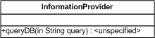
- The main functionality of the “DigitalMapProvider” class is to determine the relevant map and to provide the result to the module needing it. This class is dependent on the “InformationProvider” class as it will utilise and instance of it to query the database for information required for determining the relevant map.
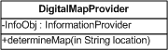
- The functionality of the “Pacings” class is rather more complex. The class is a composition (delegation) of two objects, one an instance of the “InformationProvider” class and the other an instance of the “DigitalMapProvider” class. The “Pacings” class has these object so it can utilise the functionalities of the classes they instantiate. It also implements a Listener interface from an Android OS View[16] class. The main functionality of the “Pacings” class is to use the “Result” from the “InformationProvider” object and the “Map”, which is an id, from the “DigitalMapProvider” instance to create and provide “Navigation Information” to the user, or in other words presents details in text and images explaining how the user can reach the desired destination. Being the main functional class it also extends Androids’ Service[17] class.
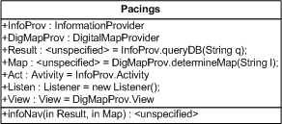
Relevant objects:
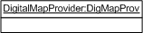
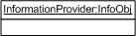
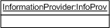

Change Management Process
The project and product will both continue to evolve, change and improve.
Record of all changes, ideas and development will be kept as until now written in the project Log Book and also included in following versions of this document or following documents such as the “Final Report”.

Design
The Design part of this document builds and adds on the previous parts of the System Requirements presented mainly in the “II. Overall Description” section of this document.
The design of the system is going to follow the modular decomposition approach.

Architecture Overview
The diagram represented by “Class Diagram 1” describes and models the basic class structure of the application. (See “Figure 9. Class Diagram 1”)
Everything the application contains is presented inside the application boundary “PACINGS APPLICATION”. The base classes “InformationProvider”, “DigitalMapProvider” and “Pacings” are contained in the application base package “project.pacings”.
- “InformationProvider” class
@extends Activity
  - Public method “QueryDB(String query)” – method which takes a SQLite query String as a parameter and applies it to the Database
@param String query – the SQLite query
@return String queryResult – the result of the query
- “DigitalMapProvider” class
@extends View
  - Private attribute “InfoObj” – instance of “InformationProvider” class
  - Public method “determineMap(String location)” – takes String variable as a parameter and uses it to build an SQLite query with which it calls the “QueryDB(String query)”, via “InfoObj”, and passes the built query as a parameter. After this it uses the obtained information to determine the required digital map and returns the decision as a String.
@param String location – desired location
@return String map – relevant to location map id
- “Pacings” class
@extends Service – because “Pacings” class is the main functional class of the application
@implements Listener
  - Public object InfoProv – instance of “InformationProvider” class in order to allow “Pacings” class to use the “InformationProvider” class functionality
  - Public object DigMapProv – instance of “DigitalMapProvider” class in order to allow “Pacings” class to use the “DigitalMapProvider” class functionality
  - Public String Result – holds value from call to “InfoProv.queryDB(String q);”
  - Public String Map – holds value from call to “DigMapProv.determineMap(String l);”
  - Public Activity Act – Activity object obtained through the instance of “InformationProvider” class
  - Public Listener Listen – models listener which will be required, obtained through implementing interface from Android OS class
  - Public View View – models View objects which will be required, obtained through instance of “DigitalMapProvider” class
  - Public void method “infoNav(String Result, String Map)” - using the information from the “InformationProvider” and the id of the map from the “DigitalMapProvider”, this method presents “Navigation Information” to the user via text and images
@param String Result
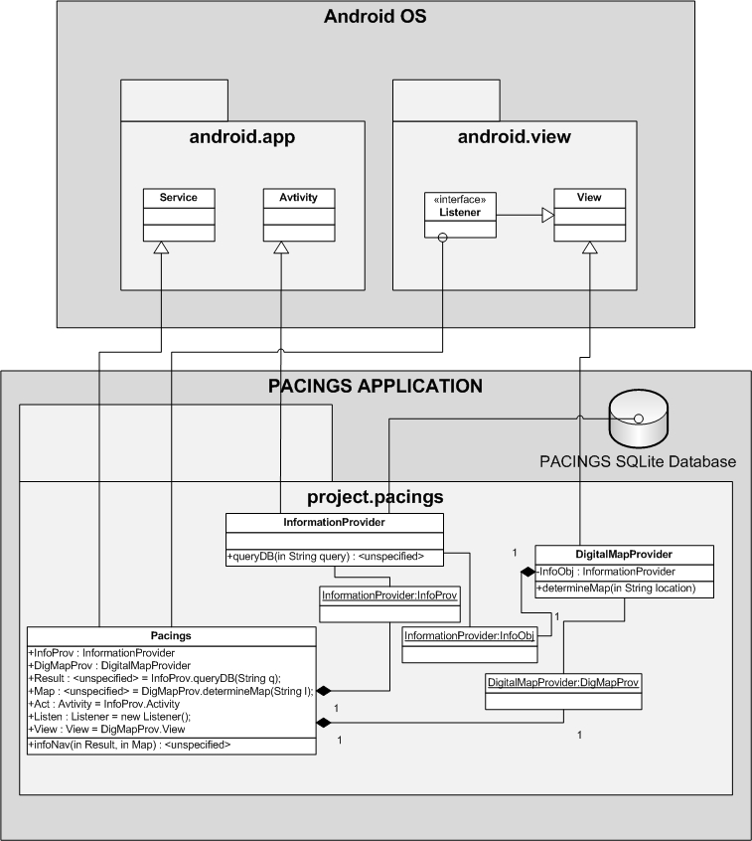
Figure 9. Class Diagram 1
@param String Map
(See “Figure 9. Class Diagram 1”.)

Design Considerations
The main design strategy is using a “Waterfall Model”[18] sequential design process. By using this design process the long life span and evolution of the product will be ensured. (See “Figure 10. Waterfall Model Diagram 1”)
Requirements
Design
Implementation
Testing
Maintenance
Figure 10. Waterfall Model Diagram 1

Architectural Strategies
My main strategy is to keep everything simple and once I have a stable, functional base of the product to build on top of it.

Architecture Types
GUI Architecture
The Graphical User Interface (GUI) is event driven in the sense that it waits for user interaction to trigger a response from the application. (See “Figure 11. GUI Diagram 1”)
- GUI Screen 1 – The first screen presents to the user the search functionality of the product with which the user can browse the desired location
- GUI Screen 2 – The second screen in the diagram models the presentation of results to the user, in this case it shows the location of the searched destination on a digital map marked by a gray circle. This way the user will get a visual idea of where the destination is and how it can be reached.
- GUI Screen 3 – The third screen is an extension of “GUI Screen 2” it models the functionality of the application when the user finger-taps the location marker (the circle) to get text information explaining how to navigate to the specified location. The navigation information will be presented in a pop-up which the user is able to hide and show again by tapping on the circle.

Find
Information about CSEE: SQ2, Entr. 1NW
TAP to get info.
CSEE
CSEE
CSEE
GUI Screen 3
GUI Screen 2
GUI Screen 1
Figure 11. GUI Diagram 1

System Architecture

System Rational

The system has a modular architecture and the base (“Level 0: Application Base”) of the system is build up of base modules. The important bit here is that the application cannot fulfil its functionality if any of its base modules is missing. This is due to the fact that these modules have strong dependencies between each other. Any additional core or interfacing modules in this or other levels are loosely connected and just add functionality. Even if they are removed at a later stage they will not affect the core functionality. (See “Figure 7. Use Case Diagram 3”)
Digital Maps subcomponent
Information/Navigation
subcomponent
PACINGS Application
Level 0: Application Base
User
PDA
SQLite DB
Figure 7. Use Case Diagram 3

Modular Decomposition Rational
*Note: For the purpose of this document the words “module” and “subcomponent” should be considered to have the same meaning.
I have used modules as an abstraction tool to deliver a better understanding of the application.
The application has a layered feel with clustered modules in the core. (See “Figure 7. Use Case Diagram 3”)
- PACINGS Application – most outer layer, container composed of functionality levels. This also interfaces the Android OS and through it, the application interfaces with the device’s hardware.
  - Level 0: Application Base – core layer consisting of modules
    - Information/Navigation subcomponent – Module clustered inside a level. This module is build up from the “InformationProvider” class and the “Pacings” class. (See “Figure 9. Class Diagram 1”.) The main purpose of this subcomponent is to allow user to search for a location and then to present the navigation information explaining how to reach it in a visual format by the means of digital images and text. The dependency between this module and the “Digital Maps subcomponent” is high because the “Information/Navigation subcomponent” relies on the other module to provide him essential information for the image representation. This subcomponent is also interfacing with the Database.
    - Digital Maps subcomponent – Module clustered inside a level. This subcomponent consists from the “DigitalMapProvider” class and an instance of the “InformationProvider” class. Its main functionality is providing essential for map selection information to other modules. It also communicates with the Database through the “InformationProvider” object.

Policies and Tactics
This is an open source[19] project.
The application is based on the open source Android Operating System and it will be developed using “Eclipse Galileo Java EE Developers”[21], “Android SDK”[22] and “SQLite”[6]. The programming language used is Java[23] as this is the language for writing Android applications.

Database Design
This section is about the SQLite database design. (See “Figure 12. ER Diagram 1”)
For more details about the database functionality please refer back to section “3.5 Logical Database Requirements” from this document.
- Purpose – To provide data storage on the device.
- Function
  - The application will only be able to query the Database.
  - An administrator can use SQLite commands and queries such as: ADD, UPDATE, INSERT INTO, CREATE, DELETE to modify the contents of the Database.
- Interfaces
  - For the purpose of this project the Database will be manually modified.
  - Future goals include development of administrator interface for automated database manipulation.
  - Only the application will be interfacing it as it will fetch data from it.
- Resources – The main reason to why the Database is local to the device instead on a server is that at this stage it is very light and it will not consume a lot of memory. Another reason is that by being local to the device it will actually save processing power by not wasting any for handling connections to a remote database.
- Data – data will be accessed and modified with SQLite queries using Java language.
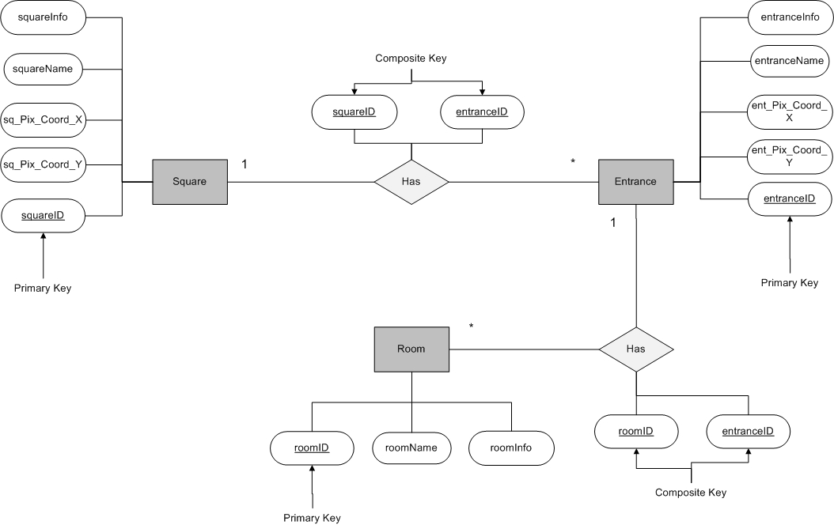
Figure 12. ER Diagram 1

Work Quality
The more I learn the more my project changes, evolves and so does my design, priorities and Project Plan. The more I dug deep into the project and the more I kept breaking down the problems I encountered, the more I realized its sheer complexity. Due to its overall high complexity I decided to change my ambitious goals in such a way that in the end I am still able to demonstrate the possible uses and benefits of this system. This is why I intend to implement an application in an initial stage, and after the changes since the Initial Report[9] the implementation will be as “Level 0: Application Base” which will include “Information/Navigation subcomponent” and “Digital Maps subcomponent”. (See “Figure 7. Use Case Diagram 3”)
After background reading, researching and testing the main technical challenges I encountered are:
- Google Maps subcomponent – After scanning through “The Google Maps Javascript API V3”[24] I have reached the conclusion that mapping image pixels to coordinates from Google Maps is highly non-trivial as a lot of problems and inaccuracies arise when it comes to resolutions, resizing and scaling.
- GPS subcomponent – My impression after reading the following thread “How accurate is Android GPS?”[25] is that high complexity due to inaccuracy would be a major drawback and possible threat to this project at this stage.
- QR Code subcomponent – QR Code reading libraries for Android platform are usually already part of an existing application or if are stand-alone are too hard to adapt to suit required needs. Writing own QR library has the complexity of a whole new project on its own, so this is not an option. As I understand from reading about the following project “zxing”[27] a lot of issues may arise and further complicate the project.
- Built-in Camera subcomponent – Directly linked to QR subcomponent and without other applications it would be pointless to implement it.
- Wi-Fi / 3G / Cell Connectivity subcomponent – High complexity and highly not relevant to the main purpose of this project. Working with any of the following technologies for Android Wi-Fi[28], 3G[29] or Cell/GSM[30] would have the same complexity as developing a separate application for each of them.
Because of the technical difficulties met, the above components have been stripped down from the main goals of this project.
Provided I have sufficient time and other resources after the implementation of “Level 0: Application Base”, being enthusiastic and passionate about this project, I will try to take the application to further development by overcoming some of the technical difficulties and implementing the relevant subcomponent – “Level 0: Application Base Extended”. (See “Figure 8. Use Case Diagram 4” in Appendix A, pages 23)
Despite the challenges met I am right on schedule with my project even after the changes made in the project Gantt chart. A lot of stages and milestones were complete successfully on time and this can be observed in the full Gantt chart located in Appendix A. (See “Figure 15. Full Interim Gantt chart” in Appendix A, pages 21, 22)
I have successfully completed the “Skills Acquisition” stage and I can demonstrate a major result by the implementation of my first “Hello World” style Android application on the virtual device emulator. (See “Figure 13. Hello Android”)
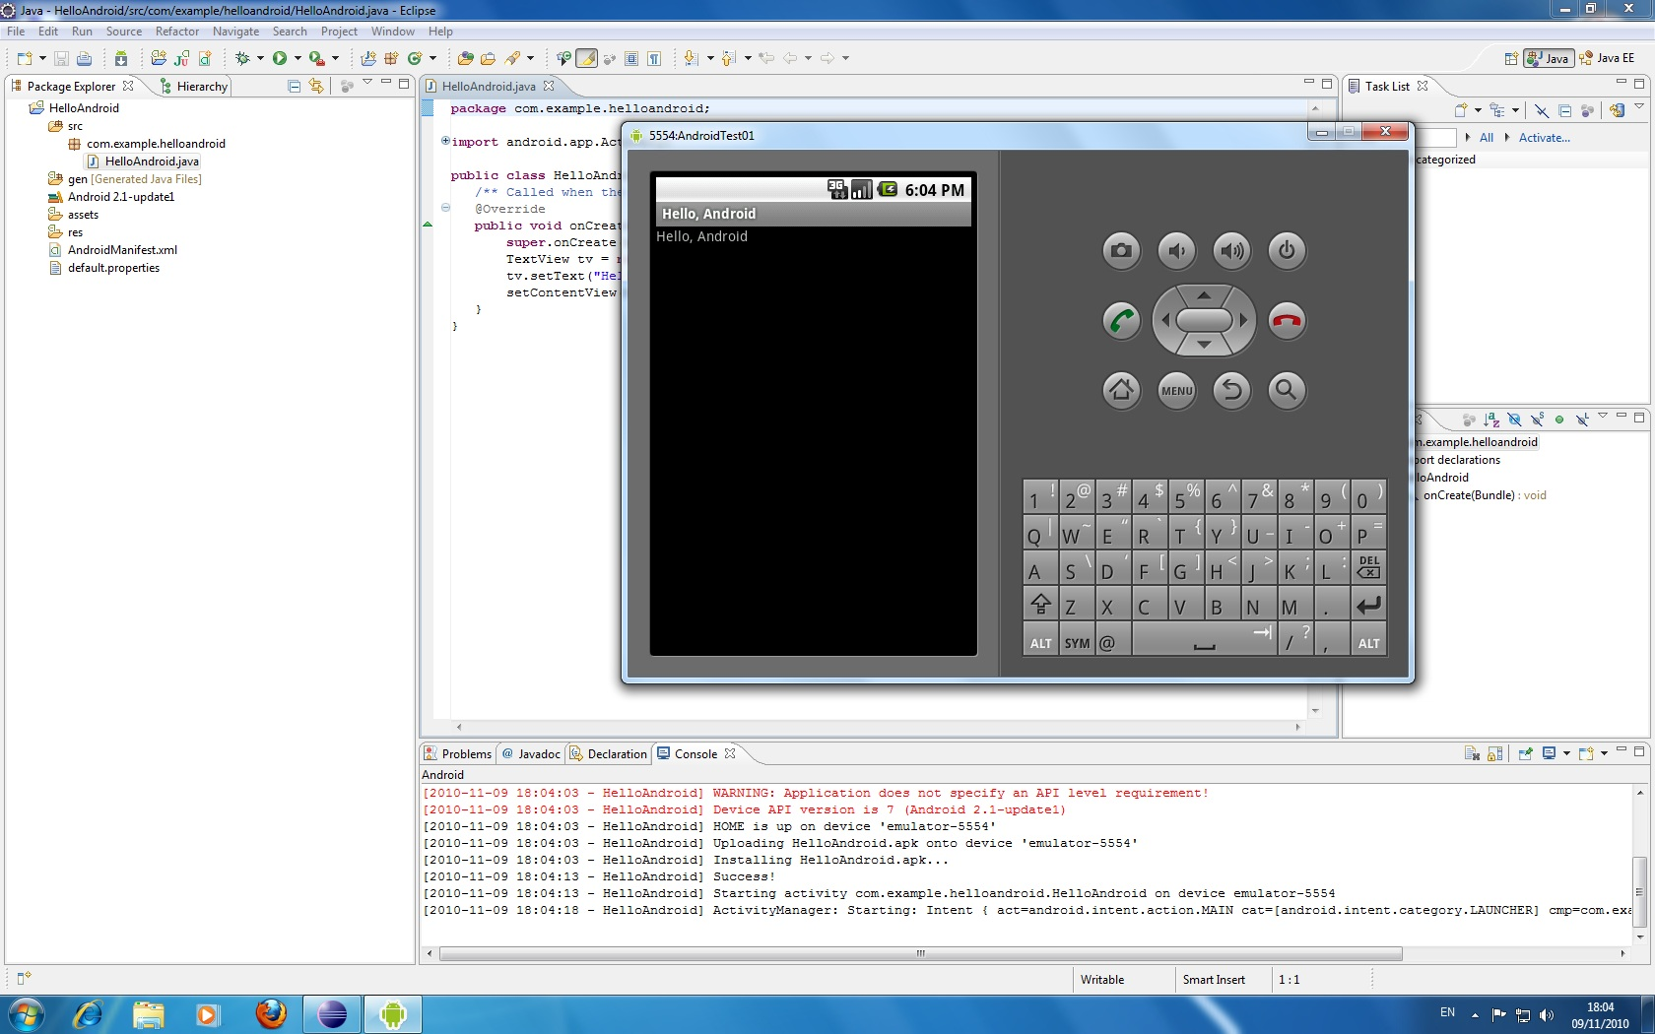
Figure 13. Hello Android
One of the main changes in the plan is the addition of the “Practical Skills Acquisition” stage. The reasons for this are that I discovered more useful ways and resources for obtaining the needed skills. I think that by going through practical exercises I will gain much more vital knowledge. (See “Figure 14. Gantt chart snippet 1”)
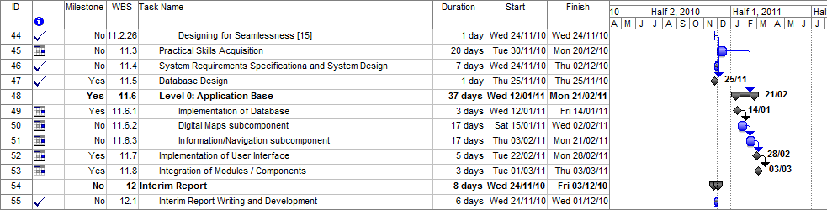
Figure 14. Gantt chart snippet 1
Other major changes took place to suit the projects’ evolved goals. They are mainly expressed in the “Level 0: Application Base” stage which replaced the previous “Level 1: Mixed Outer View / GPS / QR based component” stage. (See “Figure 14. Gantt chart snippet 1”)

The extent of this report should also serve as an indication to my deepened knowledge, progress and work quality on this project.

Bibliography and Background Reading
[1] “Android | Brand Guidelines.” [Online]. Available: http://www.android.com/branding.html. [Accessed: 30-Nov-2010].
[2] “CE201 Course Information.” [Online]. Available: http://courses.essex.ac.uk/ce/ce201/. [Accessed: 28-Nov-2010].
[3] “IEEE standard 830-1993 for SRS” [Online]. Available: http://courses.essex.ac.uk.proxy.essex.ac.uk/ce/ce201/restricted/projectDocuments2010-11/IEEE.pdf. [Accessed: 28-Nov-2010].
[4] “Design Specification for IEEE Std 1471” [Online]. Available: http://www.iso-architecture.org/ieee-1471/p1471-ds-aug97.pdf. [Accessed: 29-Nov-2010].
[5] “HTC - Products - HTC Legend - Specification.” [Online]. Available: http://www.htc.com/uk/product/legend/specification.html. [Accessed: 30-Nov-2010].
[6] “SQLite Home Page.” [Online]. Available: http://www.sqlite.org/. [Accessed: 30-Nov-2010].
[7] “Android Developers.” [Online]. Available: http://developer.android.com/index.html. [Accessed: 30-Nov-2010].
[8] “IEEE Citation Reference.” [Online]. Available: http://www.ieee.org/documents/ieeecitationref.pdf. [Accessed 30-Nov-2010]
[9] Atanas Kuzmanov, "P.A.C.I.N.G.S. – PDA Android Campus Information Navigation Guidance System", University of Essex, Colchester, United Kingdom 21-Oct-2010.
[10] D. McGookin, M. Gibbs, A. Nivala, and S. Brewster, “Initial development of a PDA mobility aid for visually impaired people,” in Proceedings of the 11th IFIP TC 13 international conference on Human-computer interaction - Volume Part II, pp. 665-668, 2007.
[11] “The Data protection Act.” [Online]. Available: http://www.dataprotectionact.org/. [Accessed: 28-Nov-2010].
[12] “University of Essex :: Home page.” [Online]. Available: http://www.essex.ac.uk/. [Accessed: 30-Nov-2010].
[13] Michael Anslow, Atanas Kuzmanov, Ahmet Soormally, Stephen Ireland, Sam Roberts, Ashly Fox, “Software Requirements Specification”, University of Essex, Colchester, United Kingdom, 19-Dec-2009.
[14] Michael Anslow, Atanas Kuzmanov, Ahmet Soormally, Stephen Ireland, Sam Roberts, Ashly Fox, “Software Design Specification”, University of Essex, Colchester, United Kingdom, 04-Feb-2009.
[15] “Activity | Android Developers.” [Online]. Available: http://developer.android.com/reference/android/app/Activity.html. [Accessed: 30-Nov-2010].
[16] “View | Android Developers.” [Online]. Available: http://developer.android.com/reference/android/view/View.html. [Accessed: 30-Nov-2010].
[17] “Service | Android Developers.” [Online]. Available: http://developer.android.com/reference/android/app/Service.html. [Accessed: 30-Nov-2010].
[18] “Waterfall model - Wikipedia, the free encyclopedia.” [Online]. Available: http://en.wikipedia.org/wiki/Waterfall_model. [Accessed: 30-Nov-2010].
[19] “Open source - Wikipedia, the free encyclopedia.” [Online]. Available: http://en.wikipedia.org/wiki/Open_source. [Accessed: 30-Nov-2010].
[20] “Mission | Open Source Initiative.” [Online]. Available: http://www.opensource.org/. [Accessed: 30-Nov-2010].
[21] “Eclipse - The Eclipse Foundation open source community website..” [Online]. Available: http://www.eclipse.org/. [Accessed: 30-Nov-2010].
[22] “Android SDK | Android Developers.” [Online]. Available: http://developer.android.com/sdk/index.html. [Accessed: 30-Nov-2010].
[23] “The Java™ Tutorials.” [Online]. Available: http://download.oracle.com/javase/tutorial/. [Accessed: 30-Nov-2010].
[24] “The Google Maps Javascript API V3 - Google Maps JavaScript API V3 - Google Code.” [Online]. Available: http://code.google.com/apis/maps/documentation/javascript/. [Accessed: 30-Nov-2010].
[25] “How accurate is Android GPS? - Stack Overflow.” [Online]. Available: http://stackoverflow.com/questions/1567443/how-accurate-is-android-gps. [Accessed: 30-Nov-2010].
[26] “Issues - zxing - Project Hosting on Google Code.” [Online]. Available: http://code.google.com/p/zxing/issues/list. [Accessed: 30-Nov-2010].
[27] “zxing - Project Hosting on Google Code.” [Online]. Available: http://code.google.com/p/zxing/. [Accessed: 30-Nov-2010].
[28] “android.net.wifi Details | Android Developers.” [Online]. Available: http://developer.android.com/reference/android/net/wifi/package-descr.html. [Accessed: 30-Nov-2010].
[29] “Settings | Android Developers.” [Online]. Available: http://developer.android.com/reference/android/provider/Settings.html. [Accessed: 30-Nov-2010].
[30] “android.telephony.gsm | Android Developers.” [Online]. Available: http://developer.android.com/reference/android/telephony/gsm/package-summary.html. [Accessed: 30-Nov-2010].

Appendix A
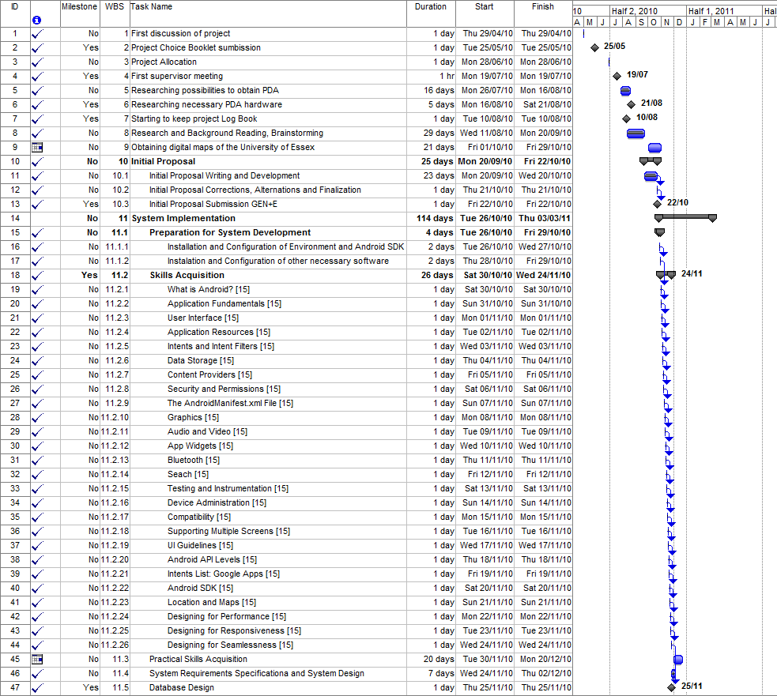
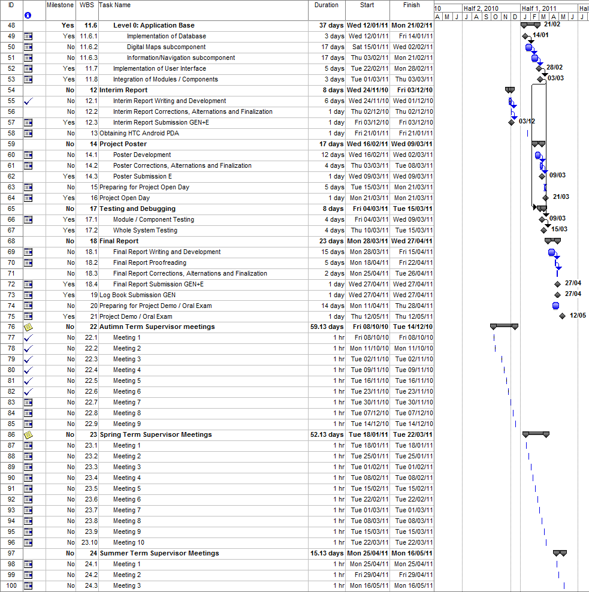
Figure 15. Full Interim Gantt chart

PACINGS Application
GPS subcomponent
C
Level 0: Application Base Extended

Google Maps subcomponent
Digital Maps subcomponent
Wi-Fi / 3G / Cell Connectivity
subcomponent
QR Code subcomponent
C
Built-in Camera
subcomponent
PDA
Google Maps
GPS
QR Codes
Information/Navigation
subcomponet
SQLite DB
User
Wi-Fi Network
Figure 8. Use Case Diagram 4

